Introduction

The Degla Event Management System is a Java-based desktop application designed to streamline the process of organizing and managing events within a structured environment. Built using JavaFX and FXML, the system supports multiple user roles including administrators, organizers, and attendees, each with distinct functionalities tailored to their responsibilities.

The primary objective of this project is to simplify event logistics, such as room rentals, event scheduling, and category management, while providing a user-friendly interface and a modular, scalable backend. Through role-based navigation and dynamic scene switching, the system ensures secure access and smooth user experience across all functionalities. This project serves as a practical demonstration of applying object-oriented programming principles and UI design in a real-world event coordination scenario.

**First of all**

As soon as the user opens the program, they are welcomed with the Log in screen. The user can choose to either Log in or Sign Up, if they can’t log in or if they do not have an account.

Admins are automatically redirected to the admin dashboard once they log in with their credentials. Organizers and attendees are also automatically redirected to their respective dashboards once they Log in

**The Admin**

plays a supervisory role in the system. They have full access to dashboards that allow them to view and manage all events, rooms, organizers, and attendees.

Admins can also perform CRUD operations on event categories and add new rooms to the system, assigning each room a capacity and a set of available time slots. This ensures that organizers have structured spaces in which to host events, and contributes to the efficiency of the event planning workflow.

To conclude, admins have the most important functions in the system and they get to see and control what enters and exits the system at all times.

**Organizers**

responsible for event creation and room reservations. Through an intuitive graphical interface, organizers can add new events by entering relevant details such as the event name, date, location, category, ticket price, and a unique identifier.

Once the event is created, the organizer can select a room from a list of available options and rent it for a specific time. Organizers also have access to information about attendees registered for their events, supporting personalized planning and audience management.

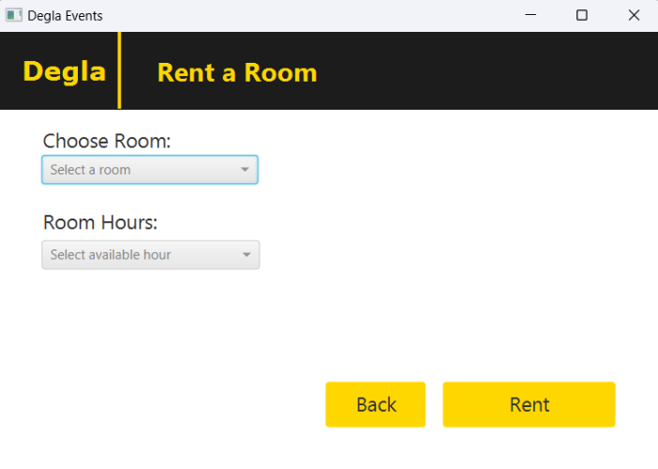

**Attendee**

can register and log into the system, where they are prompted to provide personal information such as their name, gender (using an enum type), interests, address, balance, and date of birth.

Once logged in, attendees can browse available events, view details, and purchase tickets—provided they have enough funds in their wallet. The system automatically deducts the ticket cost from the attendee’s balance and credits the amount to the corresponding organizer’s wallet.

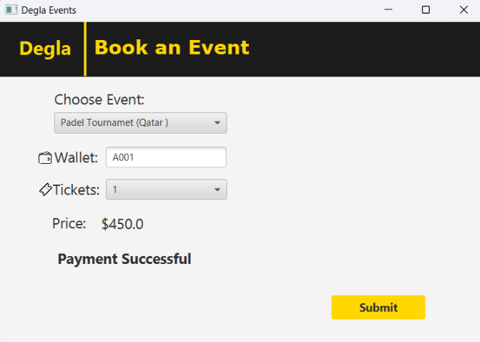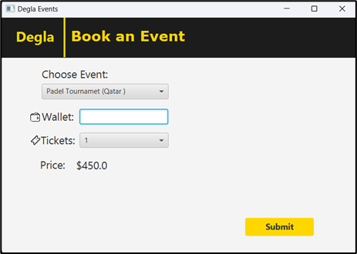

**UML**

The UML Shows all the classes used and the relationship between classes.

It also shows each attribute and method that the classes hold.

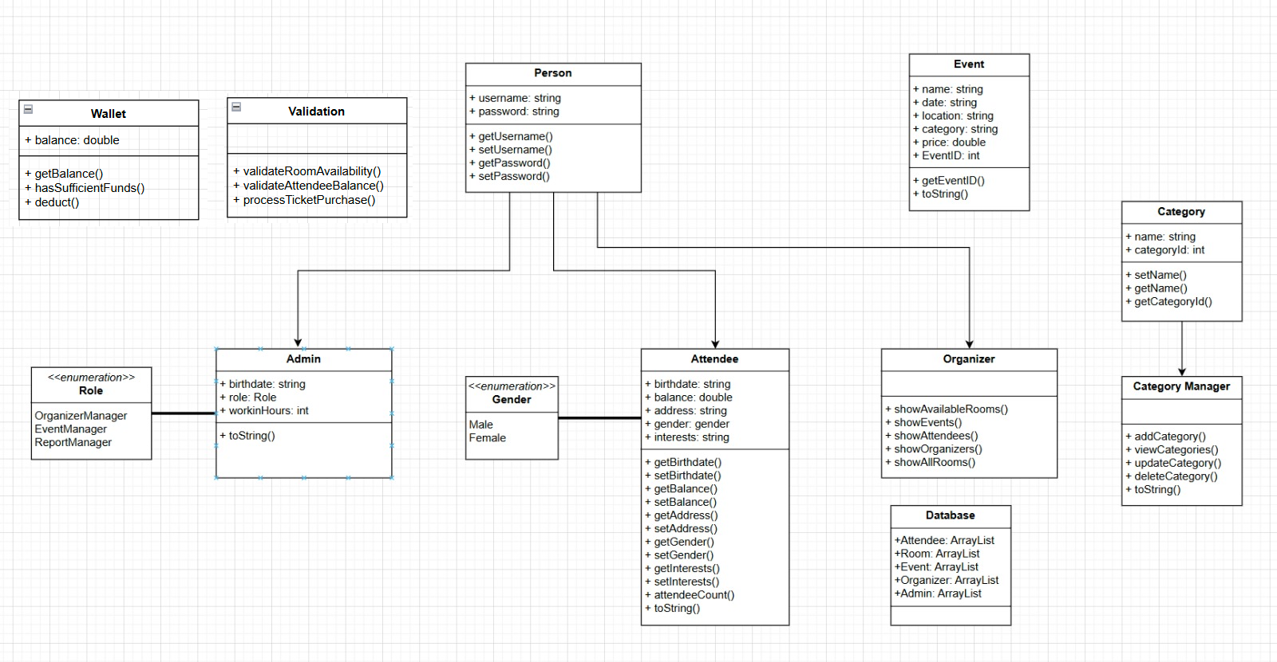

**Conclusion**

The Degla Event Management System stands as a comprehensive and structured solution for organizing events in a multi-user environment. Developed with a focus on object-oriented programming principles and implemented through JavaFX for a clean and interactive user interface.

By dividing responsibilities among Admins, Organizers, and Attendees, and by incorporating essential features such as room reservations, event creation, category management, and wallet-based transactions, the project provides a realistic simulation of how event platforms operate in the real world.

|  |  |
| --- | --- |
| ***Name*** | ***Contribution*** |
| **Ali Amr** | Attendee-FXML  Organizer-FXML |
| **Aley Abdelkader** | Event  Organizer  Category  CategoryManager |
| **Aley Ezzat** | Attendee  Room  Admin  Wallet  Log-in & Sign-out |
| **Ahmed Tamer** | Admin-FXML  Admin Controller |
| **Marawan Ayman** | Attendee  Room  Admin  Wallet |